Temporary Engineering Change Request Information
TECN Number: |  | ECN Title: | Communication System PID Monitoring
Date: | 5/09/2018 | ECN Originator: | Hyundai Rotem/Woojin/DTS
ECN Schedule: | ASAP | Component Effected: | Communication System/PID

Temporary Engineering Change Request Description
Hyundai Rotem and the communication system supplier, Woojin, are investigating the random and constant
PID Power failures that have been experienced over the past year of revenue service.
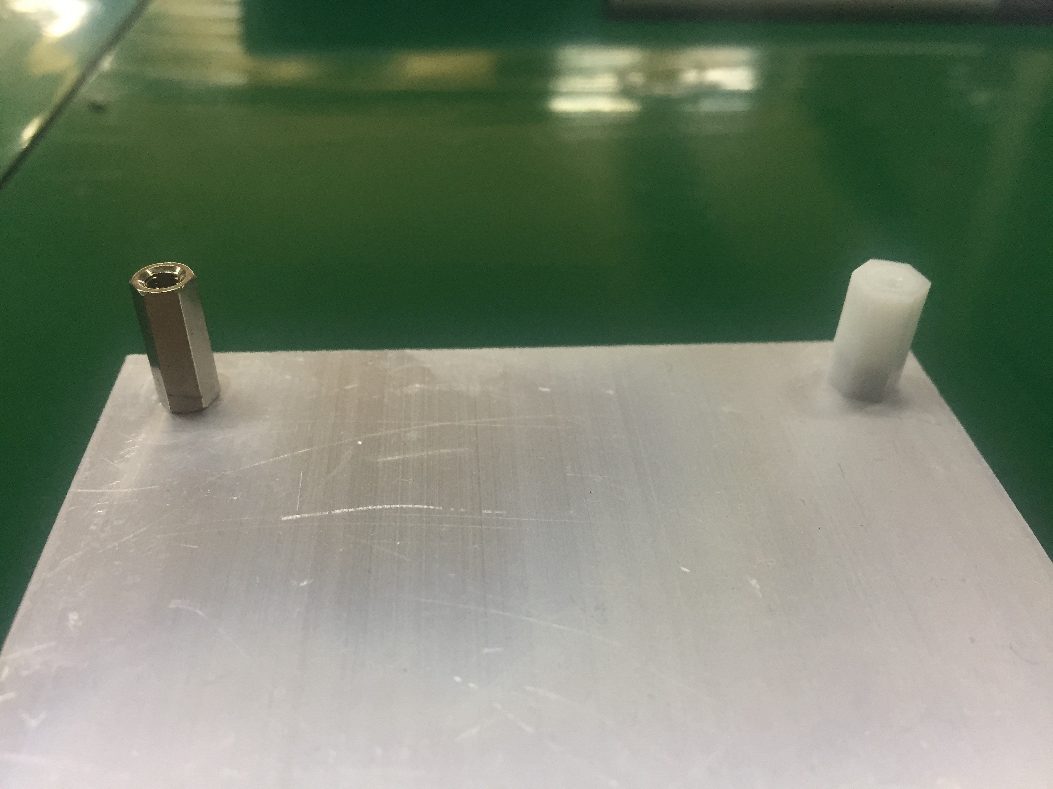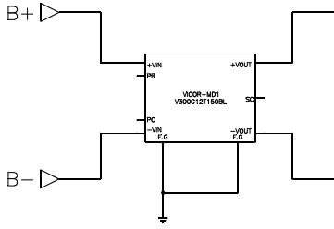
Before
(stainless material)
after
(Polyacetal material)
<PID Power Support>
Noise blocking.
VICOR 모듈
Woojin has investigated the causes with the power module manufacturer(VACOR), and assume that the
noise input through the power FG is a major cause of fault. Therefore, we expect to apply the car FG noise
cut as a complementary measures.
Woojin expect to work on car 4035-4036, 4047-4048 which the failure occurred and monitoring for two
months to find out the solution. And this supplementary work will be taken 1 Day per cars.

Temporary Engineering Change Required Documents
 | Required | Supplied
Work instructions:
Design drawings:
Technical description:
Maintenance manual:
Parts list / manual:
Test plan:
Test procedures:
Interface documents:
Communication plan:

DTO Configuration Management Board Approval
Title | Date | Approved (Y/N) | Printed Name | Signature
General Manager |  |  | Anne Herzenberg
Chief Engineer |  |  | Mario Santiago
Chief Transportation Officer |  |  | Frank Hauser
Chief Mechanical Officer |  |  | Carl Atencio
Chief Safety Officer |  |  | Barry McGauley

Disposition (Circle the one that applies)
Approved As Submitted | Approved With Modifications | Rejected See Attached Explanation | Resubmit Changes Required

Distribution Instructions:
Original – DTO Document Control Permanent Record
1 copy DTO Chief Engineer 1 copy DTO Chief Mechanical Officer
1 copy DTO Chief Transportation Officer 1 copy – Originator

